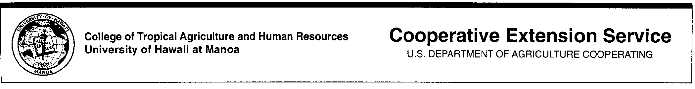
Financial Preparedness Checklist

An important part of emergency preparation is financial planning for unexpected events.

Get ready…
- Assess potential risks to your family and getting adequate insurance to protect your family’s health, life and property. Create a financial safety net in the event of job loss or disability. Seek the advice of legal and financial professionals to ensure you meet the needs of your current situation.
- Protect important financial and legal records
- Preparing loved ones to cope with recovery in the event you are not there to care for them.

Use this checklist as you make your arrangements. Copies of these important documents will be valuable for evacuations and rebuilding efforts.

Emergency Preparedness Records*

 | Not Applicable/  In Progress | Done
Birth, death and marriage certificates
Divorce and child custody papers
Adoption papers
Passports
Military records
Social security cards
Copies of driver’s license
Mortgage/property deeds
Stock and bond certificates
Car titles
Life & health insurance policies (life, medical, dental disability, long term care) Type, company, policy number and name or insurer
Homeowners, renters insurance
Auto, motorcycle, boat, or other vehicle insurance
Auto, motorcycle, boat, or other vehicle title papers
Copies of power of attorney, advance medical directive, medical power of attorney, guardianship papers
Trust documents
Household Inventory
State & Federal tax returns (3 years)
Medical Information:
Immunization/medical condition records
Prescriptions
Letter of instructions to survivors

* Home safes are convenient but they can be damaged by tsunami, flood or hurricanes. Safety deposit box at your financial institution may be more secure but not easily accessible in an emergency.

